1. Use Case Flow

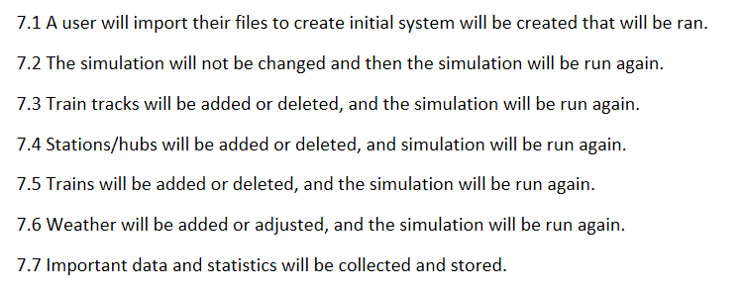

1. Use Case Diagram

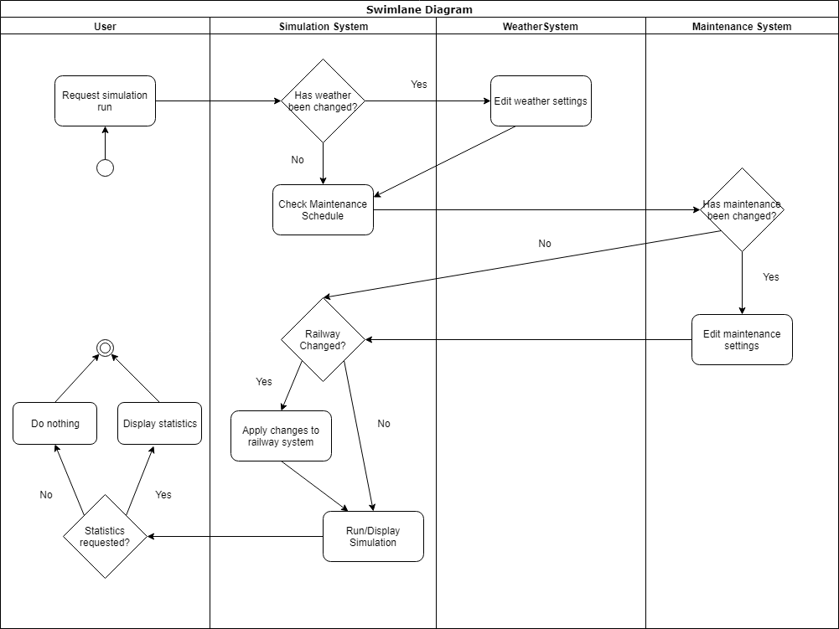

1. ERD

N/A

1. DFD

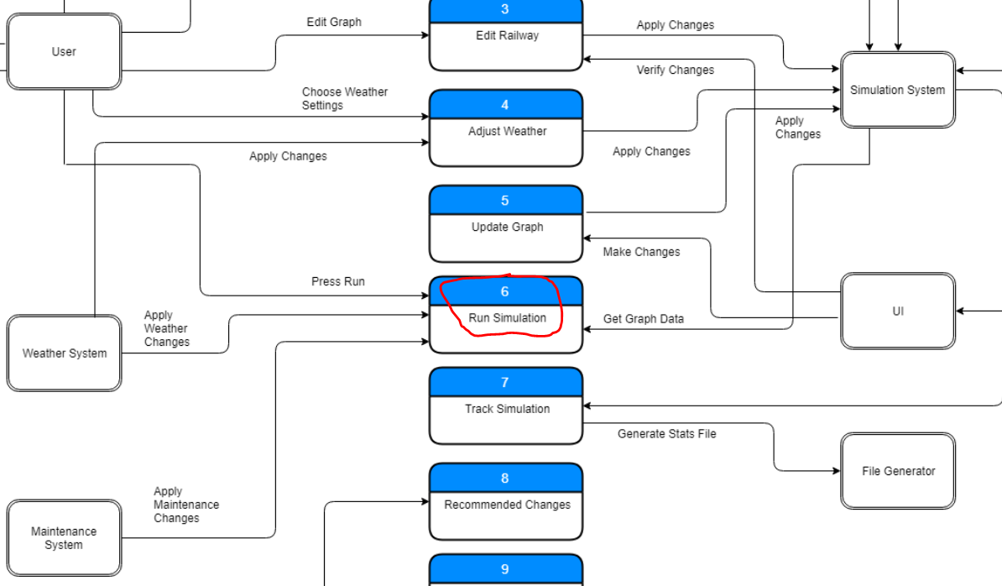

1. Communication Diagram

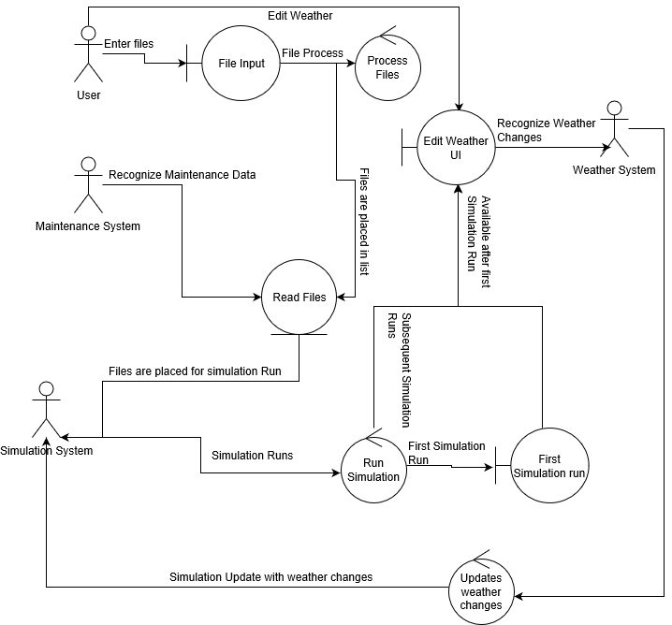

1. CRC Card

N/A

1. Class Diagram

N/A

1. Architecture Diagram

N/A

1. Algorithm

N/A

1. Sequence Diagram

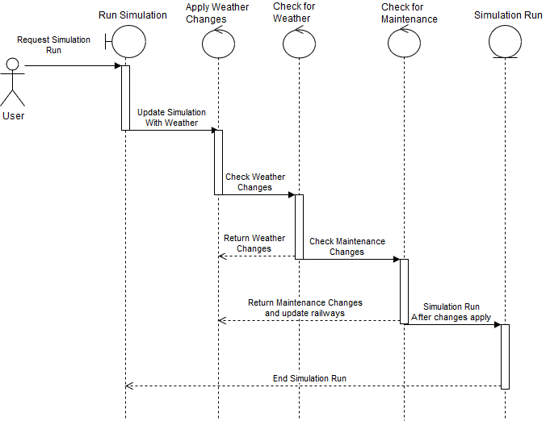

1. Code

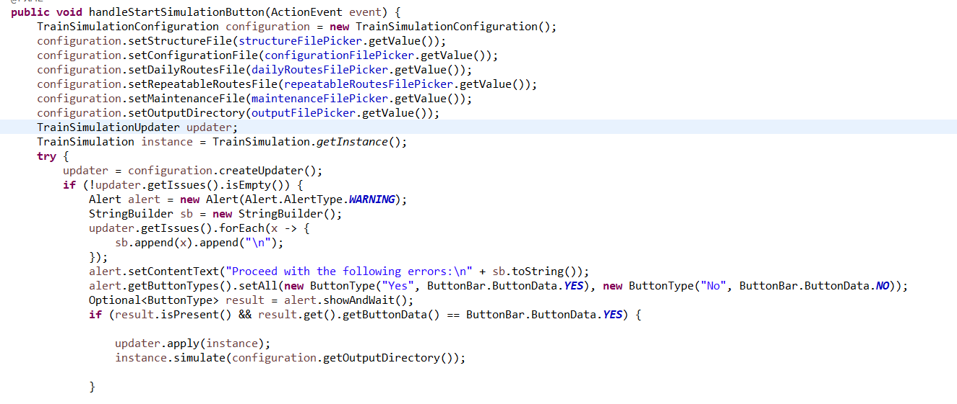

1. Execution

